1. Add hwo.mobile, org.universaal.android.felix(svn\android\trunk), personal_safety.sms (C:\universAAL\svn\new_services\trunk\personal_safety) and service.helpwhenoutside projects to your workspace
2. In hwo.mobile java Build path:
   1. Projects: org.universaal.android.felix, personal_safety.sms3
   2. Libraries: android.jar (C:\Program Files (x86)\Android\android-sdk\platforms\android-8)
3. Compile everything
4. Set the “run configurations” of service.helpwhenoutside to this:   
   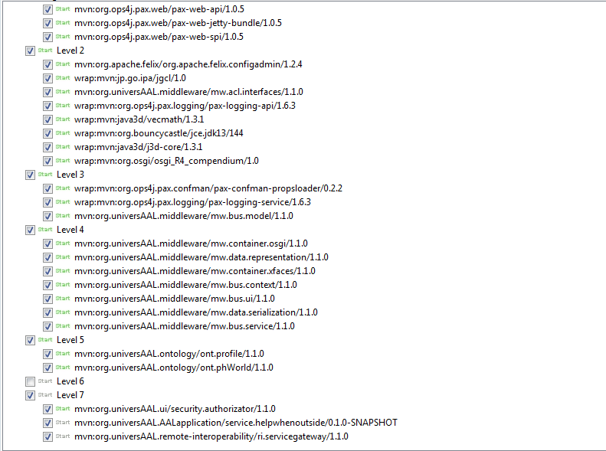

And make sure that everything in the Bundles tab is unchecked.

1. Run service.helpwhenoutside. Type “ps” in Eclipse console. Everything should be “active” but 2 elements. Start in this order: Platform component servicegateway, Help When Outside.
2. Go to firefox. Open 2 webs: <http://127.0.0.1:8080/mapeditor>, <http://127.0.0.1:8080/whereis> Modify “mapeditor” to your own settings of safeArea, homelocation, pois, etc.
3. Convert the hwo.mobile. jar to .dex, put it in the felix 110 “auto” folder (make sure you have all the other bundles put in the right folders as well).
4. Copy the files “homePosition”, “poiList” and “safearea” (from C://user/persona/helpwhenoutside in Windows) to the tablet (sdcard/data/felix-conf-1.1.0/conf/hwo.mobile/servlet)
5. Start Universaal application in the tablet.